4. Develop a mobile application that takes the user input and sends it to IoT device (python code). print the received data in python shell.

Keep a text box to accept the user input.integrate a submit button.

whenever user enters the text input in text box and clicks the button the data should be sent to IBM cloud using URL(HTTP API)

CODE:

import wiotp.sdk.device

import time

import random

myConfig = {

"identity": {

"orgId": "glif1g",

"typeId": "sarahdevice",

"deviceId":"060801"

},

"auth": {

"token": "06082001"

}

}

def myCommandCallback(cmd):

print("Message received from IBM IoT Platform: %s" % cmd.data['command'])

#m=cmd.data['command']

client = wiotp.sdk.device.DeviceClient(config=myConfig, logHandlers=None)

client.connect()

while True:

client.commandCallback = myCommandCallback

time.sleep(2)

client.disconnect()

APPLICATION UI:

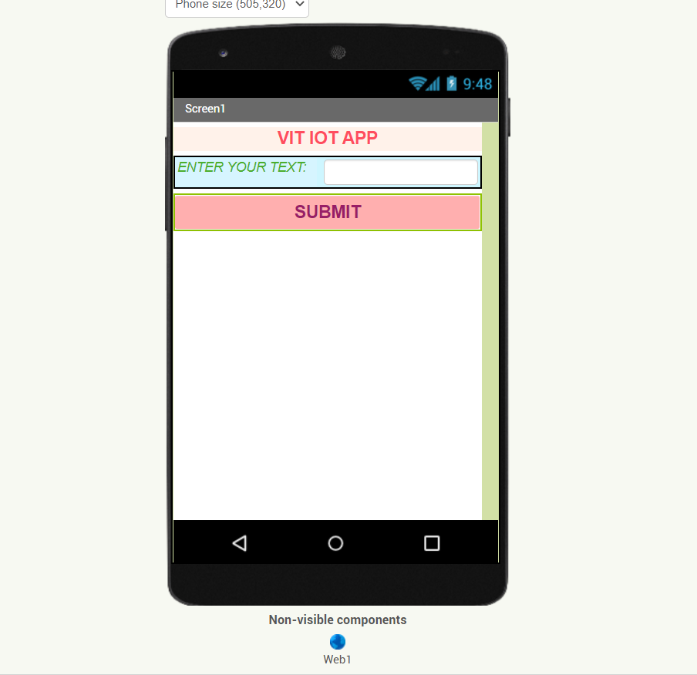

BLOCKS TO FUNCTION THE ABOVE UI:

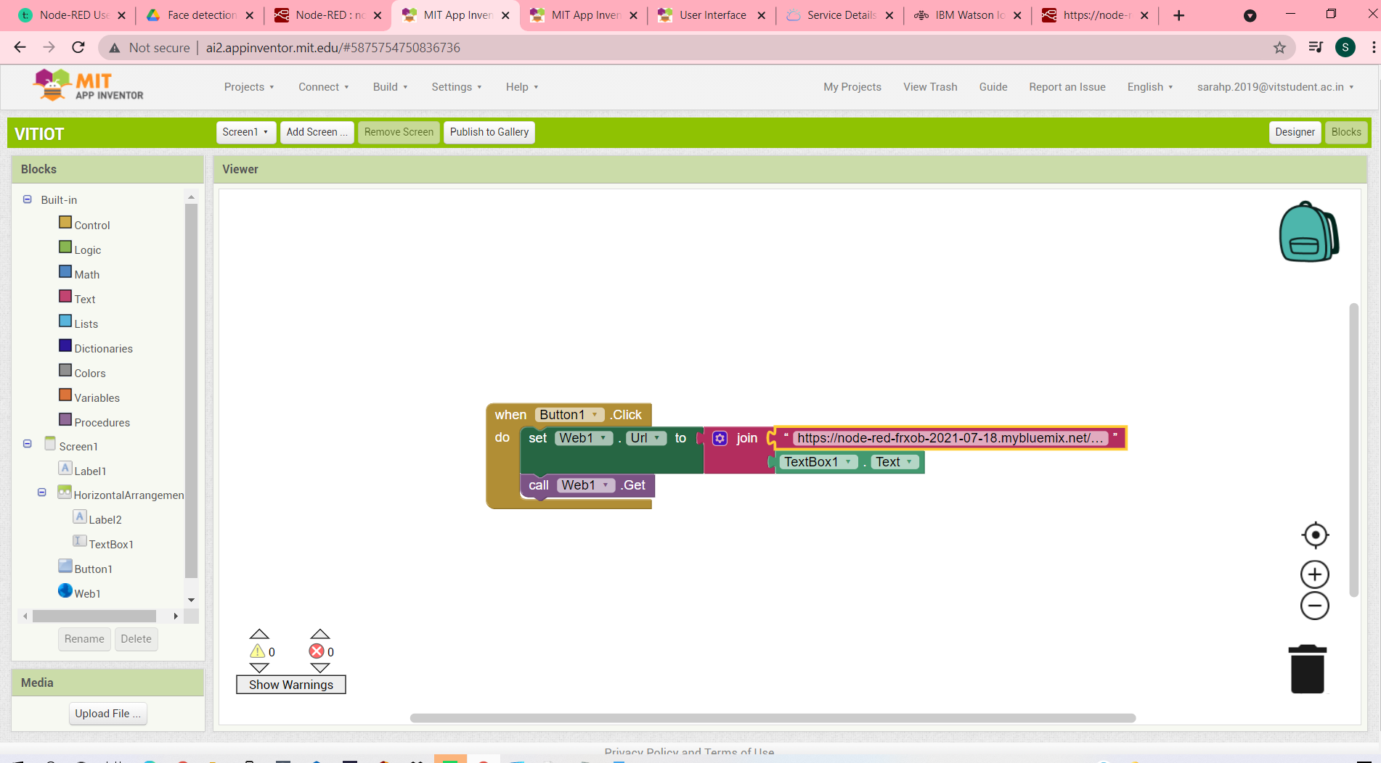

Node-Red FLOW THAT CONNECTS THE IBMIoT WITH THE APPLICATION

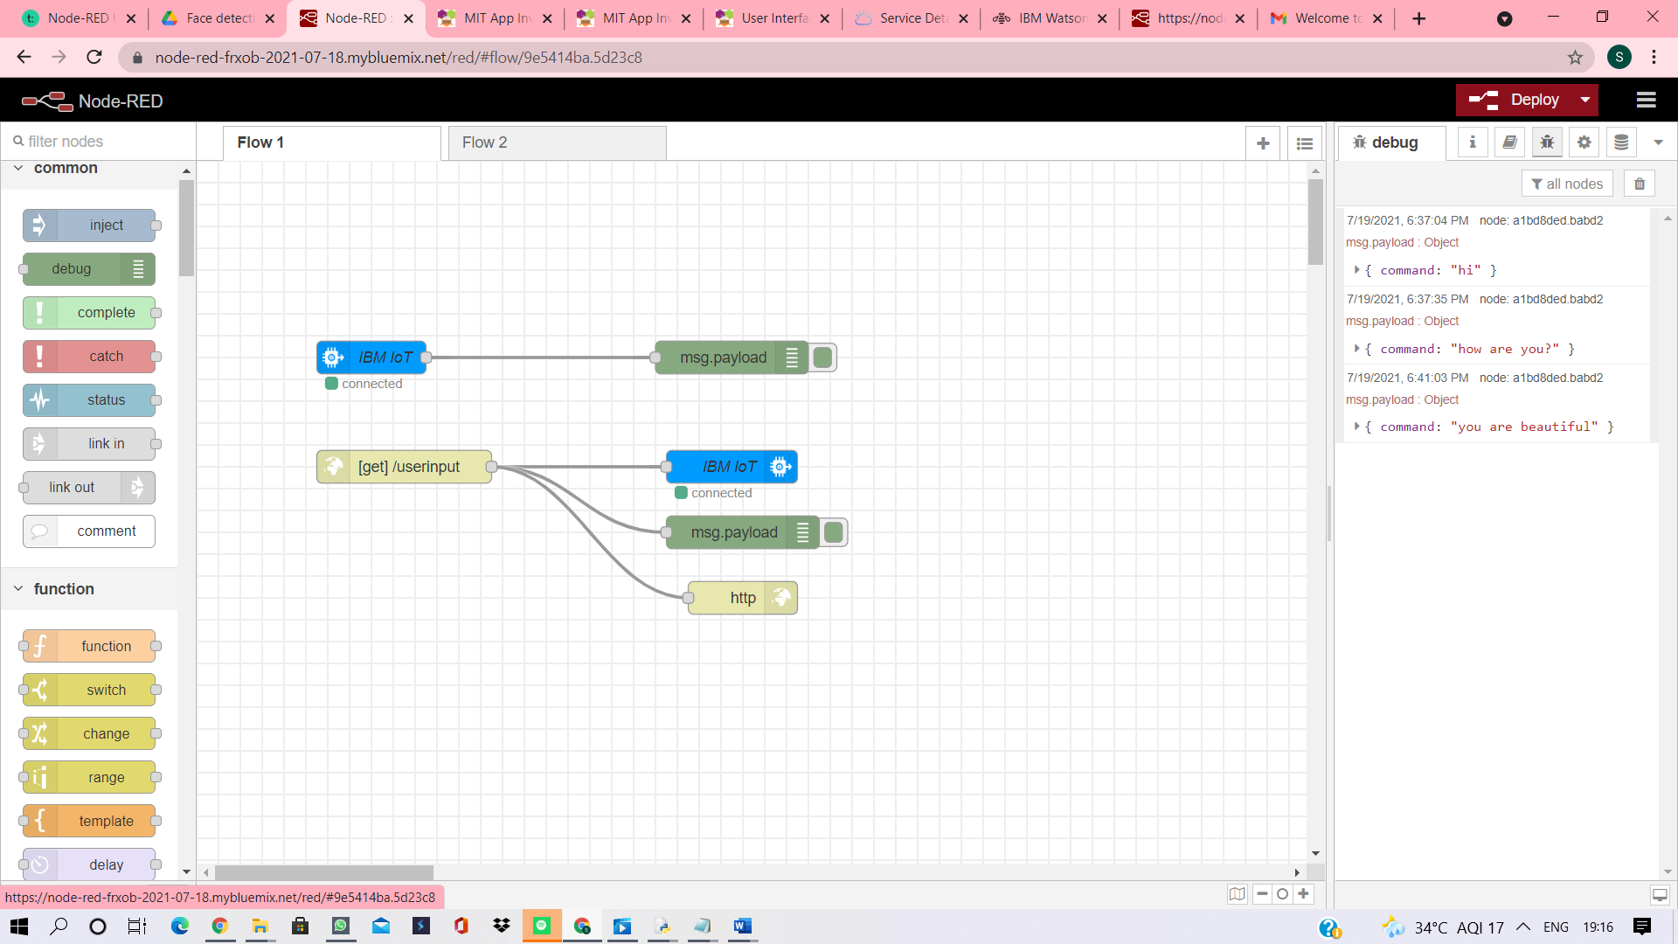

INPUT THROUGH APP

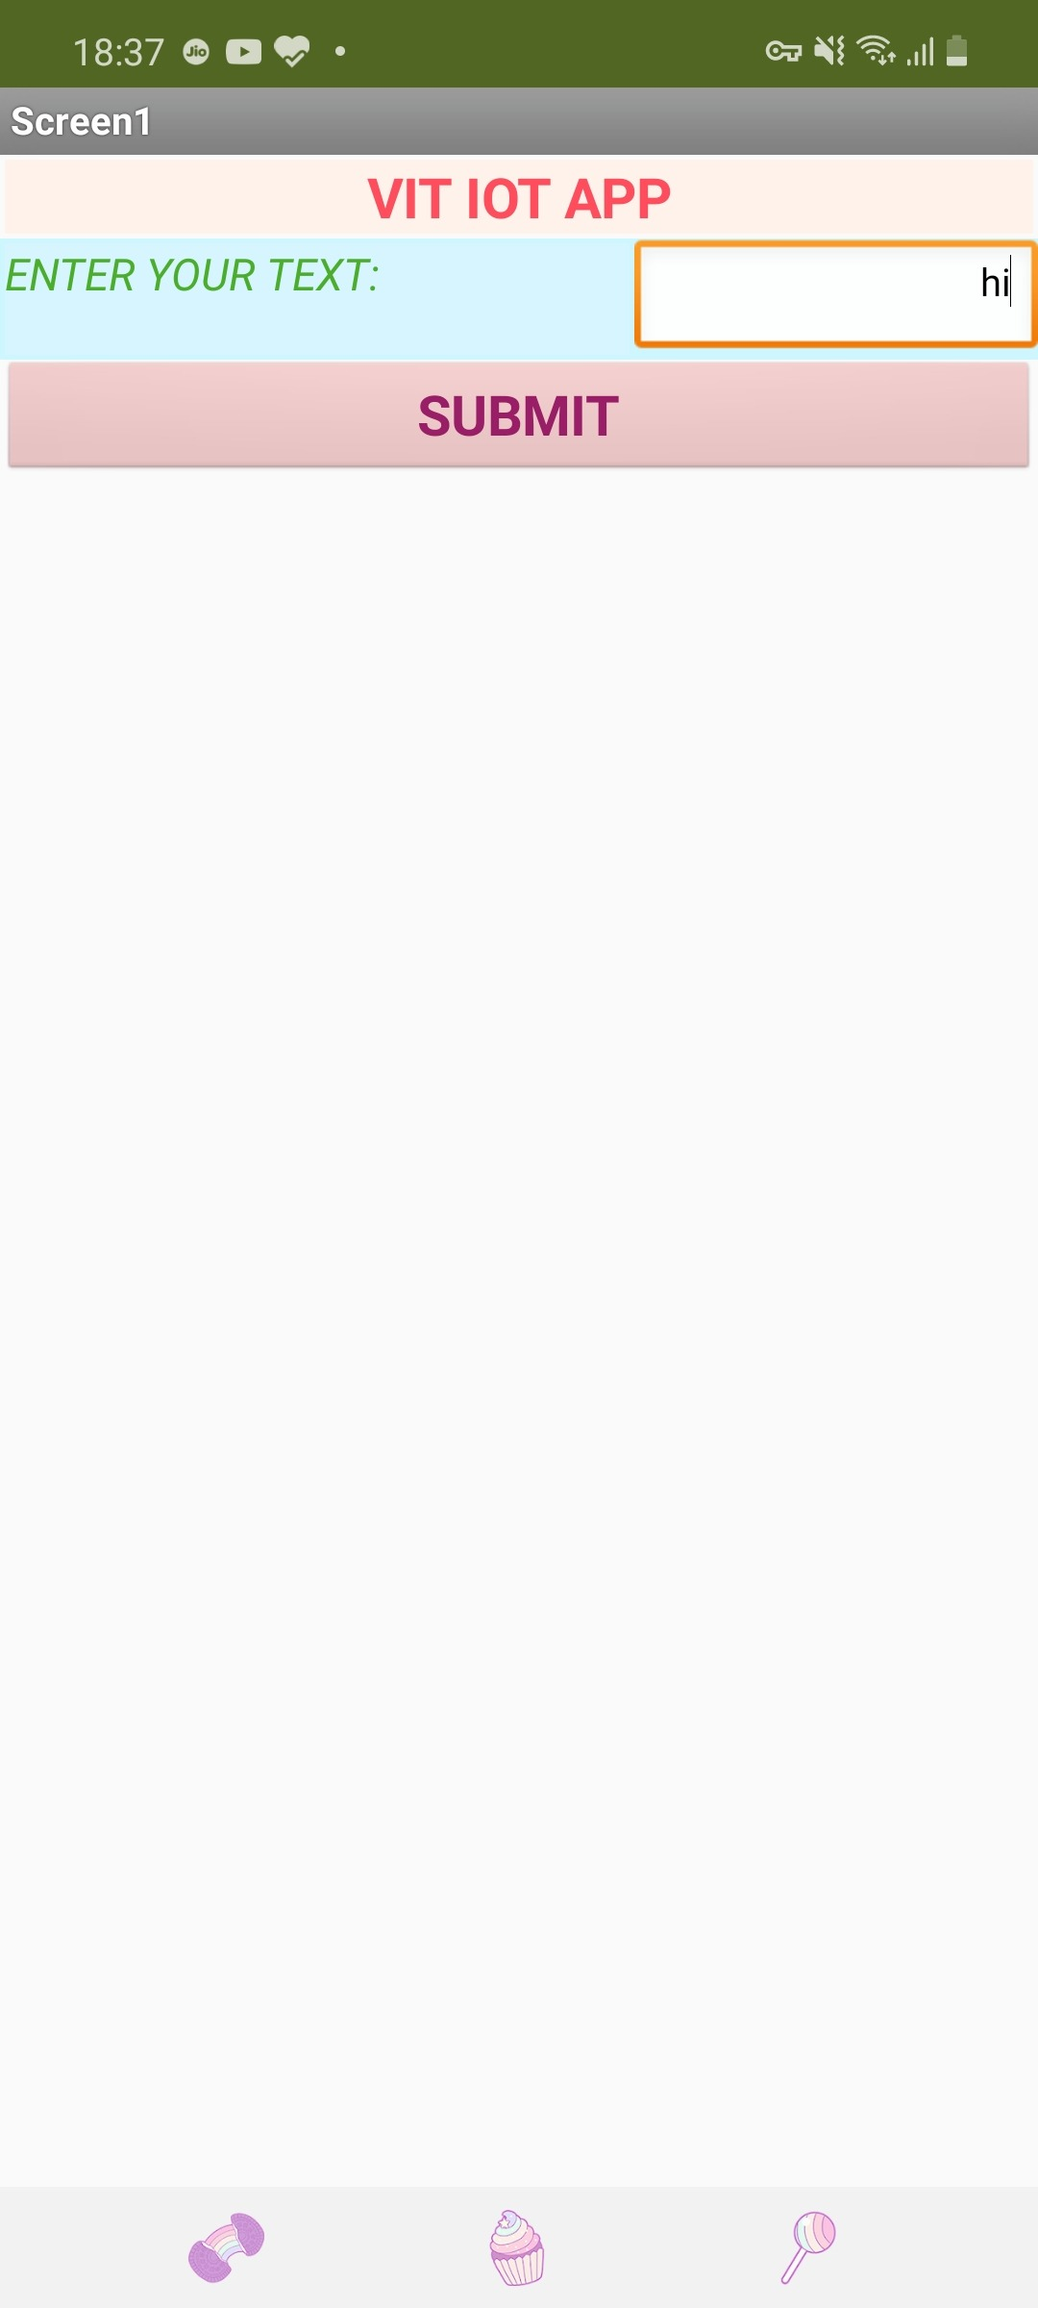

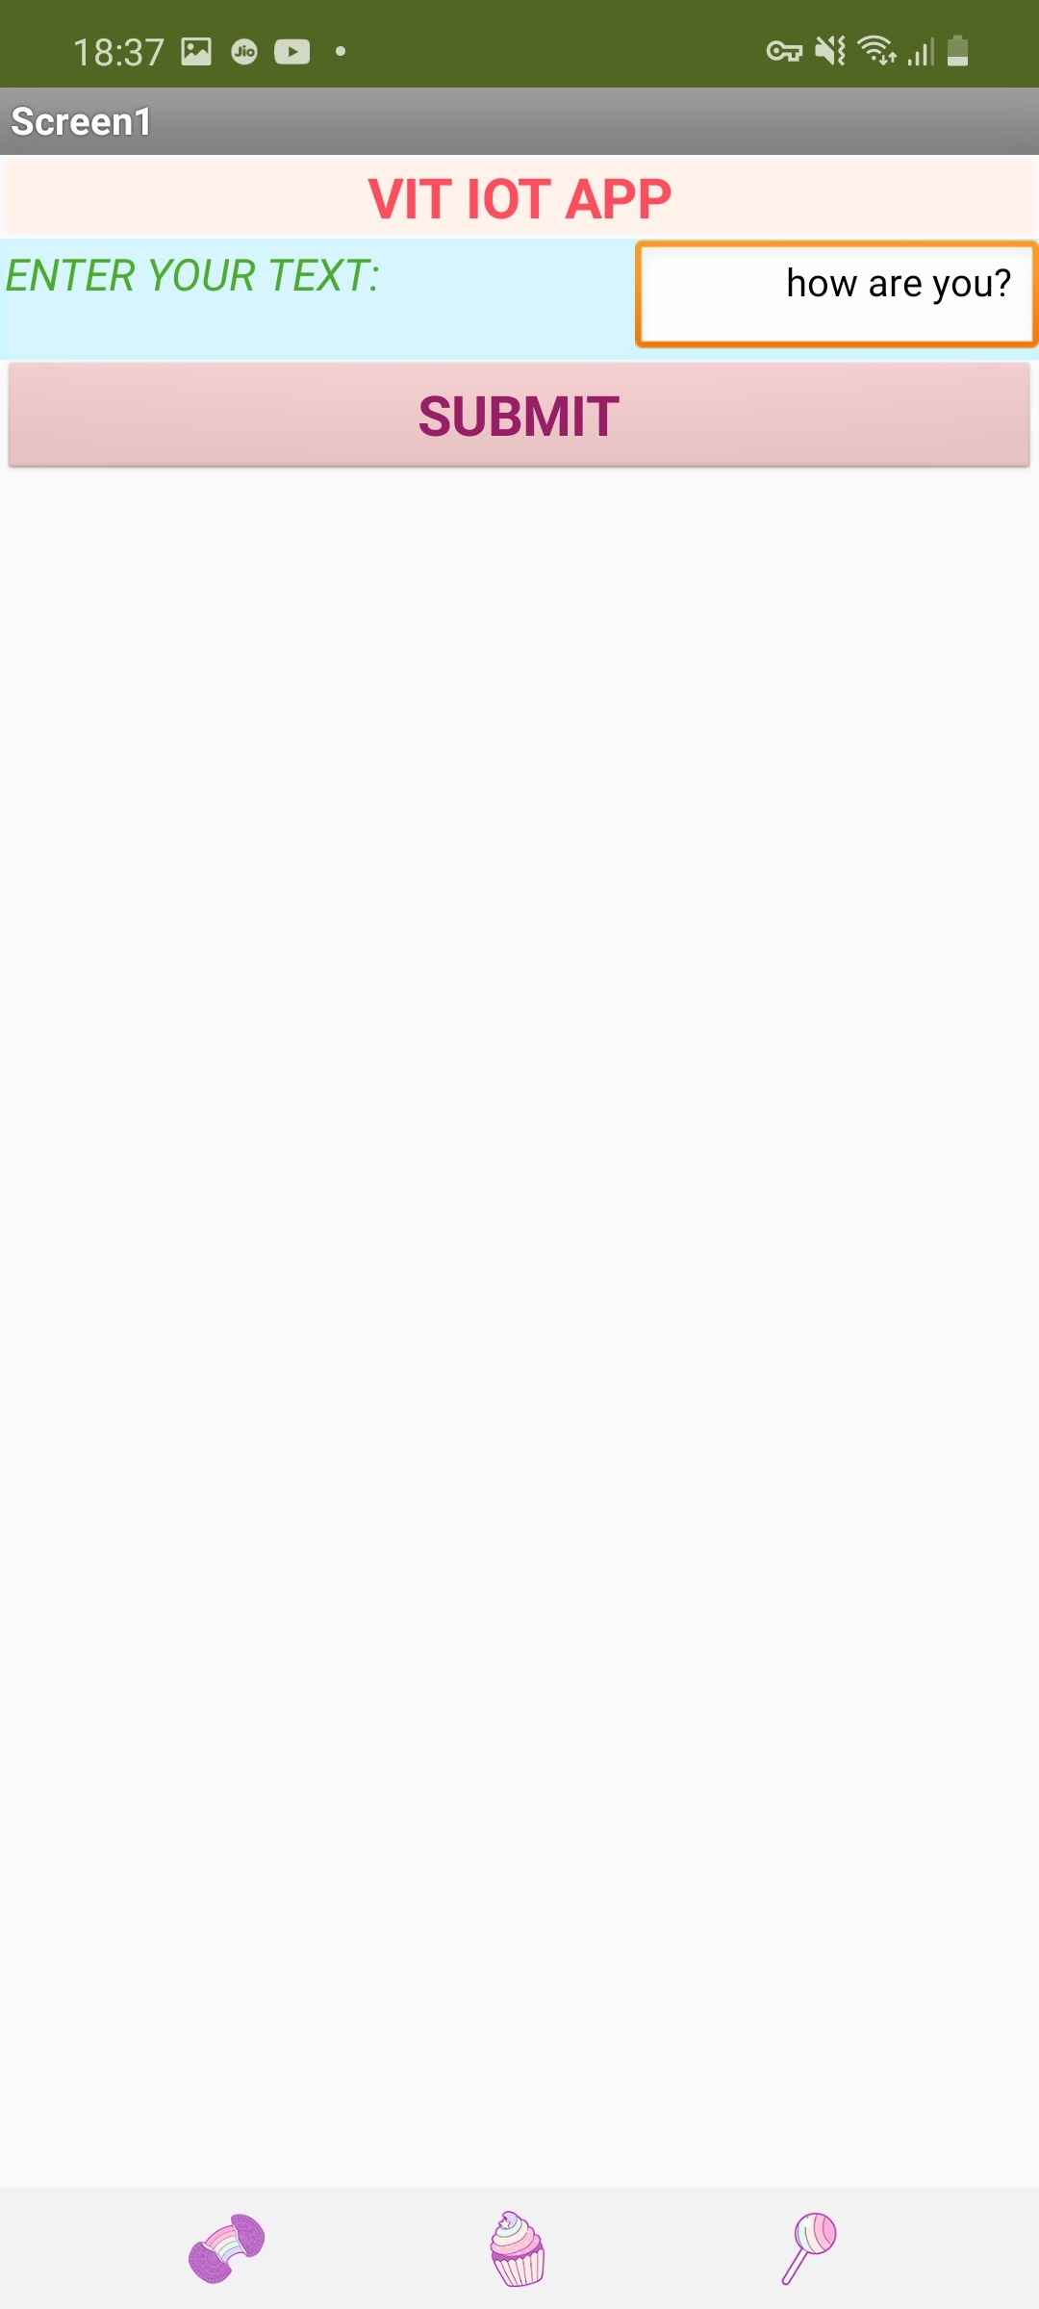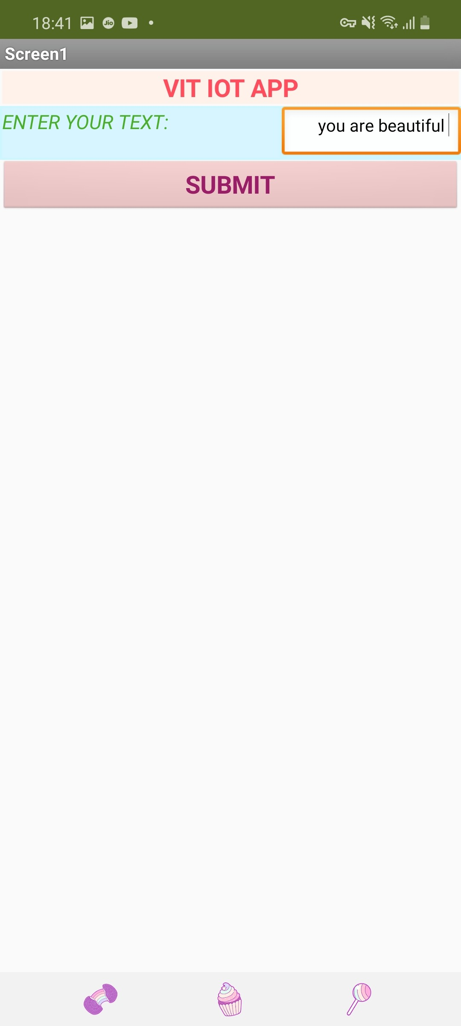

OUTPUT:

Node-Red DEBUG SCREEN:

